DEVELOPE A WEB APPLICATION USING NODE RED

| Date | 17 November 2022 |
| --- | --- |
| Team ID | PNT2022TMID26825 |
| Project name | Project-Real Time River Water Quality Monitoring And Control System |
| Maximum Marks | 4 Mks |

DEVELOPE A WEB APPLICATION USING NODE RED:

1. Double-click the tab with the flow name, and call it Earthquake Details.
2. Click the hamburger menu, and then click Manage palette. Look for node-red- node- open weather map to install these additional nodes in your palette.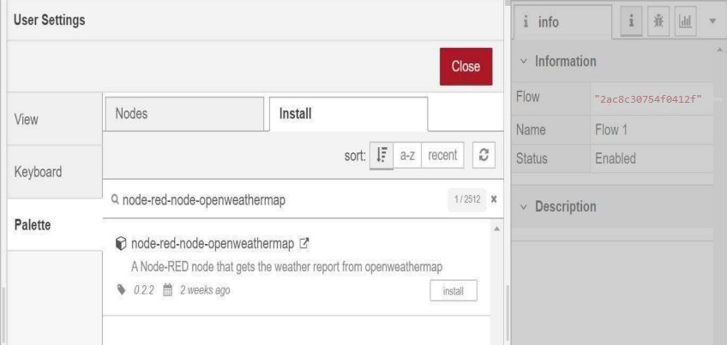

Add an HTTP input node to your flow.

Double-click the node to edit it. Set the method to GET and set the URL to

/ earthquake info-hr.

1. Add an HTTP response node, and connect it to the previously added HTTP input node. All other nodes introduced in this sub-section is to be added between the HTTP input node and the HTTP response node.
2. Add an HTTP request node and set the URL to https://earthquake.usgs.gov/earthquakes/feed/v1.0/summary/all_hour.geojson,

the Method to GET and the Return to a parsed JSON object. This will allow extracting all earthquakes that occurred within the last hour.

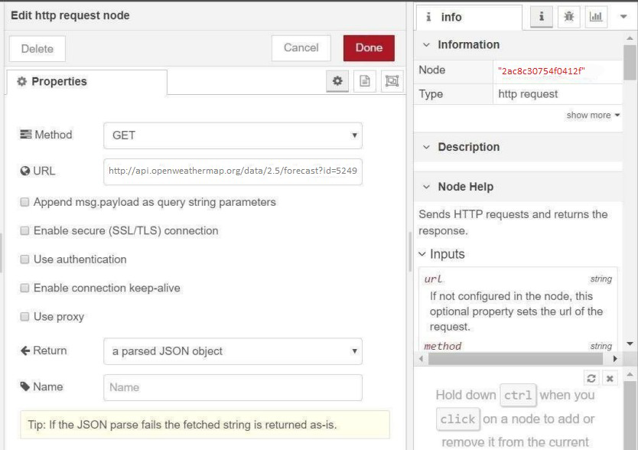

Add a change node. Double-click the node to modify it. Name this node Set Earthquake Info. In the Rules section, add rules to Delete msg.topic, msg.headers, msg. Status-code, and msg. response Url and msg.redirectList t and Set msg. payload features.

{

"type":properties.type, "magnitude": properties.mag, "location": properties.place,

"longitude":geometry.coordinates[0], "latitude":geometry.coordinates[1], "depth":geometry.coordinates[2], "timestamp": $fromMillis( properties.time)

}